**Car-Rental**

**System Architecture Analysis**

**Biniam Arefaine: 110972**

**Dawit Hailu: 110974**

**Essey Tezare: 986469**

Contents

* System Architecture Analysis
* Key Abstractions

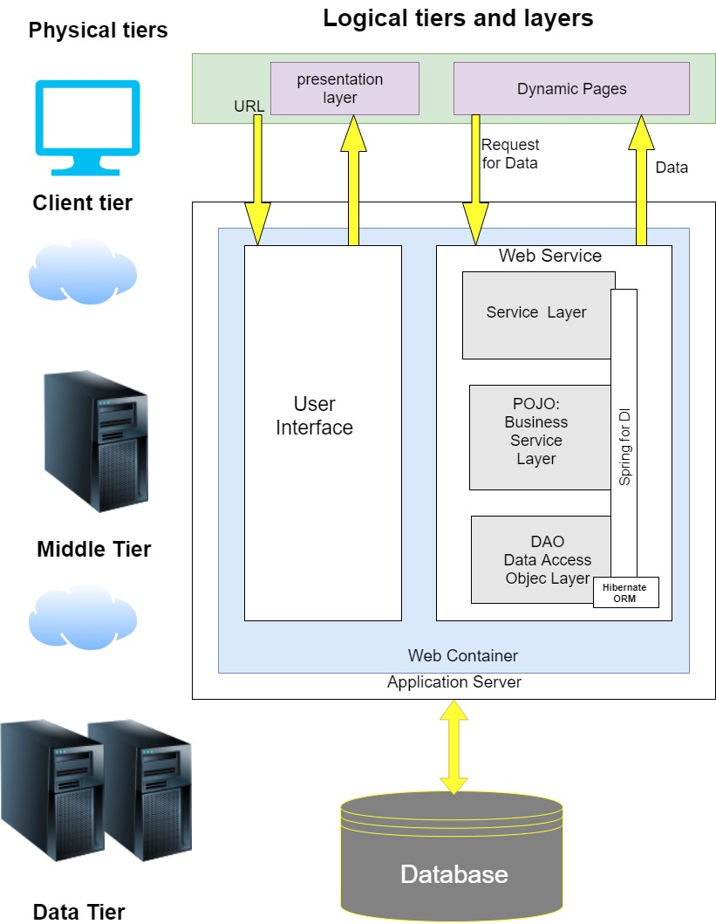

* **Key Abstractions**

1. Vehicle
2. Staff
3. Customer
4. Booking
5. Address
6. Payment
7. Classification